**Supply List 2020-2021**

**Kindergarten**

1. Back pack (no wheels)
2. 4 boxes of 24 count **Crayola** crayons
3. Two packages of thick washable markers
4. 10 glue sticks
5. 1 **plastic** pocket folder without Brads (labeled with student’s name)
6. a 1” 3 Ring Binder with clear plastic on the front
7. 2 packages of #2 **Ticonderoga** pencils
8. Girls snack size Ziploc bags
9. Boys gallon size Ziploc bags
10. 2 boxes of tissues
11. Boys 1 roll of paper towels
12. Girls baby wipes
13. 1 magic eraser
14. 1 pack of paper plates (to be used for crafts)
15. 1 resting mat labeled with student’s name on the end (Red & Blue 45x19 mat ONLY)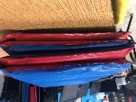
16. Air freshener, Renuzit (not the spray)
17. 2 containers of Lysol or Clorox wipes
18. White ceramic (square or circle) plate 10 ¼” labeled with student’s name (found at the Dollar Tree)
19. 1 plain natural 5x7 wood frame labeled with student’s name (one that is similar to the picture)

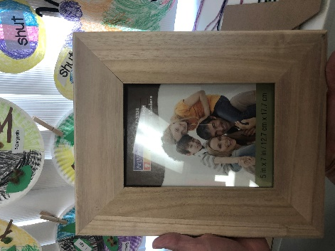

**Technology (Ms. Vallario):** lightweight headphones with no volume control (if new to school or last years are broken) labeled with student’s name

**\*\*\*Optional**

Any items that you would like to donate to our Treasure Box & playground would greatly be appreciated.

Example: stickers, plastic animals, plastic rings, cars, pencils, chalk, bubbles etc